Feedback Caregiver Dashboard

Feedback given from FHP students testing the Caregiver Dashboard

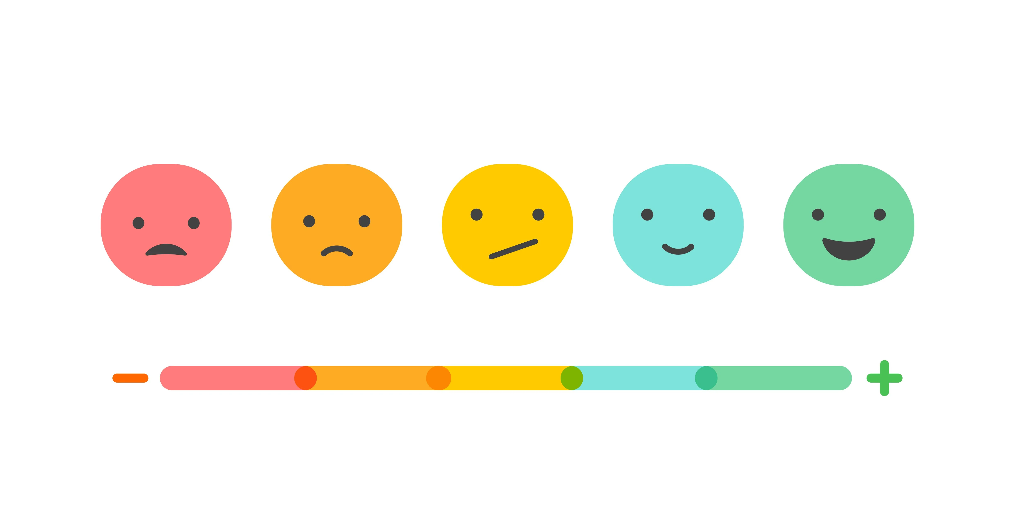

**Group Name:** Marinda Boshoff, Michael Osuntuyi, Milan Koster van Groos, Victoria Fong

**Documented by:** Victoria Fong

**Year:** 2022

**Class:** S-A-RB-CMK 4

# Context

This document is based on the user feedback received from the FHP students to the useability of the platform and what features can be added to the dashboard as a caregiver, user & physiotherapist perspective.

Test Cases / Usability Testing

**Goal:** for feedback and testing usability of the system.

|  |  |  |  |
| --- | --- | --- | --- |
| Steps | Task | Functions/Not functions | Feedback |
| 1 | Log into the Dashboard with the Caregiver password and email. |  |  |
| 2 | Locate the Patient Groups. |  |  |
| 3 | Edit a patient name and last name. |  |  |
| 4 | View a patient stress data. |  |  |
| 5 | Return to the main page. |  |  |
| 6 | Log out of the system. |  |  |

## Sections Description

### Category

|  |  |
| --- | --- |
| Log In | Features that can be added for logging in and out of the software. |
| Comments | Regarding the ability to add and edit comments with added information that is useful to know regarding a stress point. |
| Graph | Information that can be added to the stress point of the graph. |
| Notifications | How a patient & caregiver would like to be notified with also what they would be notified on. |
| Stress Data of Patient Page | what can be added for more user-friendly functionality. |
| Caregiver Dashboard Main Page | what can be added for more user-friendly functionality. |

### Users

* **Patient**: Stress data of whom is being tracked.
* **Caregiver**: person who is taking care of the patient.
* **Physiotherapist**: User who takes care of medical information of a patient.
* **Everyone**: for all users using the platform.

# Summary of Feedback

|  |  |  |
| --- | --- | --- |
| **Category** | **User** | **Feedback** |
| Log in | Everyone | Adding two factor authentication. |
| Comments | Everyone | Add a label to whether the stress point was negative or positive. |
| Comments | Everyone | Section for category of what the patient was doing. Example sleeping, eating, walking etc. |
| Graph | Everyone | When looking at a point, you can see who has written the feedback. |
| Graph | Everyone | Negative and Positive stress points on the graph are indicated with color such as red for negative and green for positive. |
| Graph | Everyone | Label x and y axis on the graph with heartrate and date. |
| Graph | Everyone | Adding range of dates to view data over that range.   * A week for a caregiver * A month for a healthcare provider |
| Graph | Physiotherapist | Setting a baseline of heart rate of a patient and their range for stress before a caregiver can track if a patient is stressed with the correct information. |
| Notifications | Caregiver | Indicating if the patient is stressed. |
| Notifications | Patient | Indicating when stressed and to add a comment at stress point. |
| Notifications | Everyone | Being able to modify the notification by example the sound, turning off or on, from who to receive notifications from. |
| Stress Data of Patient Page | Caregiver | Seeing basic information of a patient such as age, gender and who to contact as in doctor of the patient.  For privacy reasons, the gender and age can be switched for a link to more personal information of a user. |
| Stress Data of Patient Page | Everyone | Icon or indication to how to return from the stress data dashboard to the main page with, for example an arrow. |
| Stress Data of Patient Page | Caregiver | Abilities to add personal notes to a patient such as their age and gender for legal reasons. Of not using medical data but the notes of the caregiver. |
| Caregiver Dashboard Main Page | Everyone | When returning from the stress data page, show the Patient group that was opened by the user instead of having to search for the patient group again. |
| Caregiver Dashboard Main Page | Caregiver | Having a button to indicate a summary of the patients stress level over patients of the previous day to give the caregiver some input of the user. |